**LANDING PAGE:**

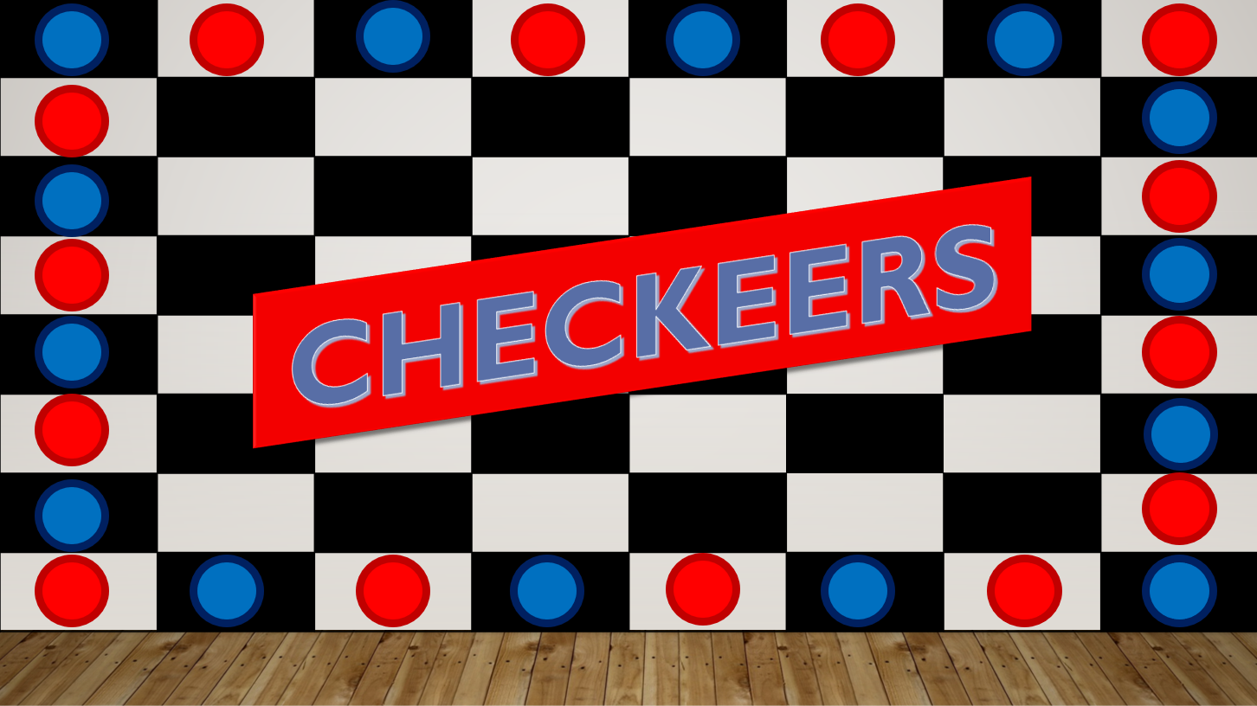

This is the front page of Checkers game displaying name of our game “Checkeers.”

The layout is like that in the background we have an image of checkers’ board.

Pieces are arranged on the border in order to beautify front page.

(This is the pre-designed basic layout of the landing pages in the game.

It might change over the time.)

**HOME PAGE:**

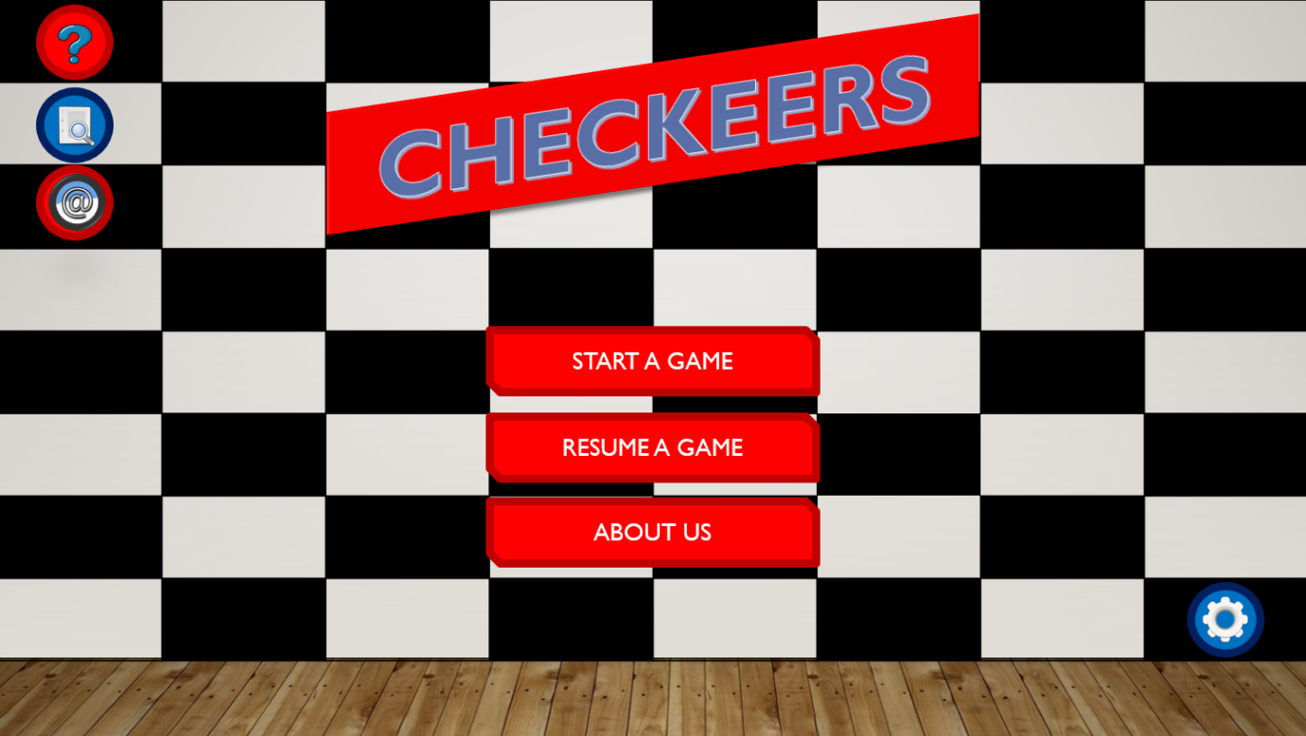

This is our home page. In the middle, we have three options for the user to select i.e., Start a Game, Resume a Game and About Us.

To start a new game, user must click on Start a Game and similarly for resuming a game, user has to click on Resume a game. In About Us section, text file will be open displaying the details what Checkeers is all about and team description.

On the left side, we have three buttons, Ask, Instructions, Contact Us.

In Ask, there will be basic FAQ’s regarding the functionality of each button.

In Instructions, rules of the game will be shown discussing about moves, jumps, captures and crowning.

In Contact Us, the email will be provided in case of any query.

**Pointing on a button:**

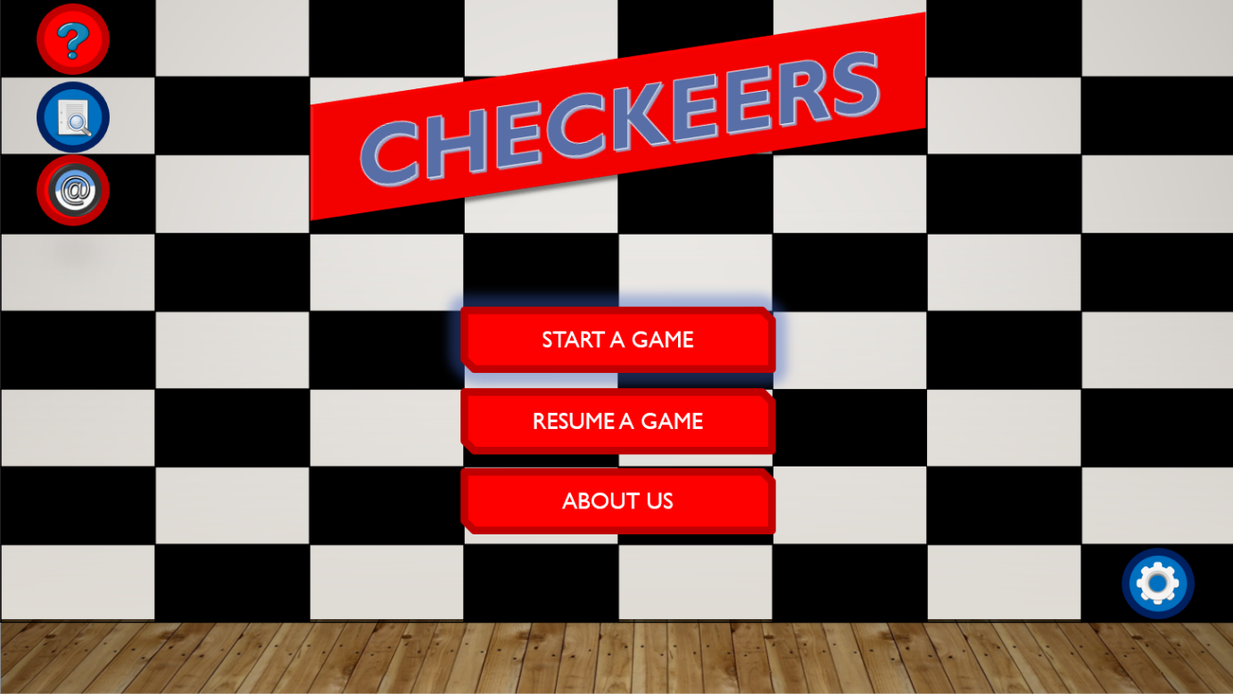

When you take your courser to any of the button it will glow.

So that you can see that which option is selected so that user will not click on the wrong button.

It will also add effects in the design part to look more attractive and classier.

It also helps you to select the correct option

**Pointing on an icon:**

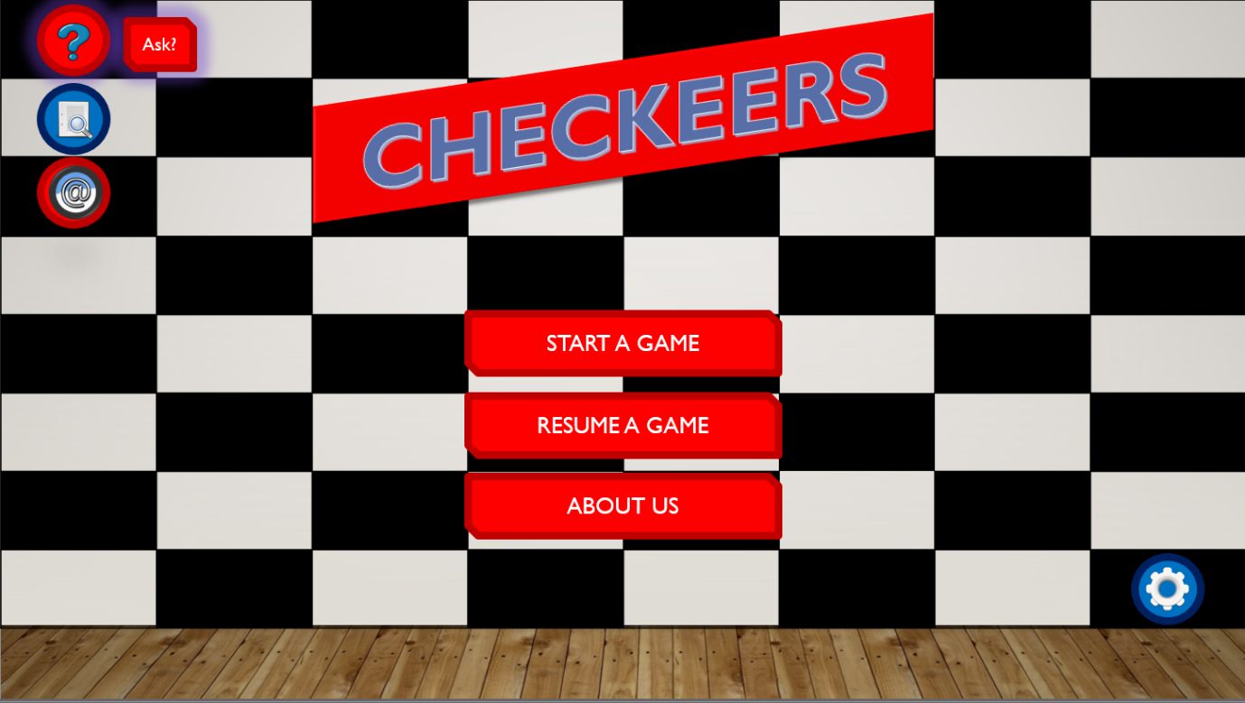

When you take your courser to any of the icon that is present on both side of the screen (left and right).

It will glow to show which icon you have selected right now.

With glow, it also shows the name like when you take courser on question mark sign it show a pop-up of Ask?

Show that user come to know what is the name of that icon and what will happen when you click on that icon.

**Initial Board Look:**

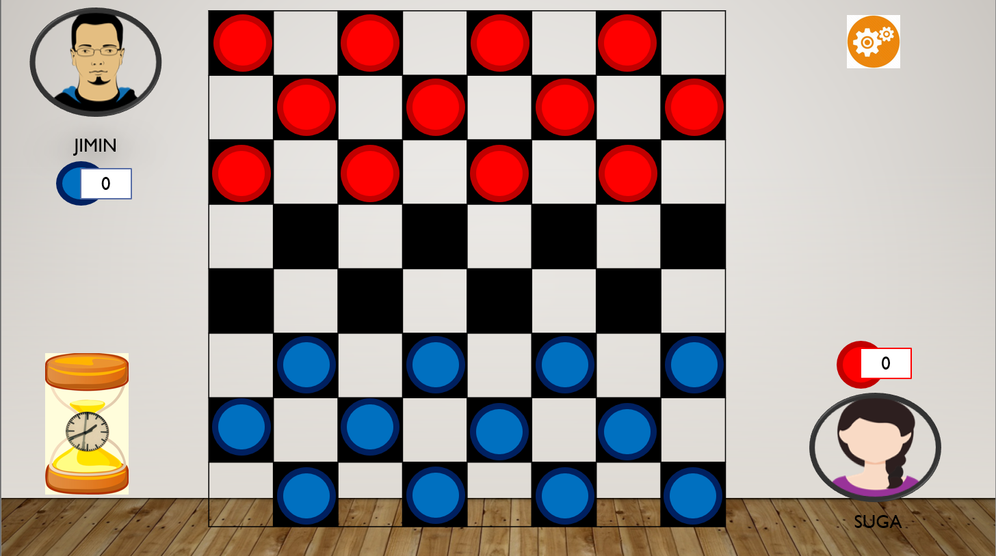

Checkers is played by two persons who oppose each other across a board of 64 light and dark squares, the same as a chessboard.

The 24 playing pieces are disk-shaped and of contrasting colours (whatever their colours, they are identified as red and blue).

At the start of the game, each contestant has 12 pieces arranged on the board.

While the actual playing is always done on the dark squares. and their points will also be noted down.

As the players starts the game the timings will also start side by side.

**When you point on a key:**

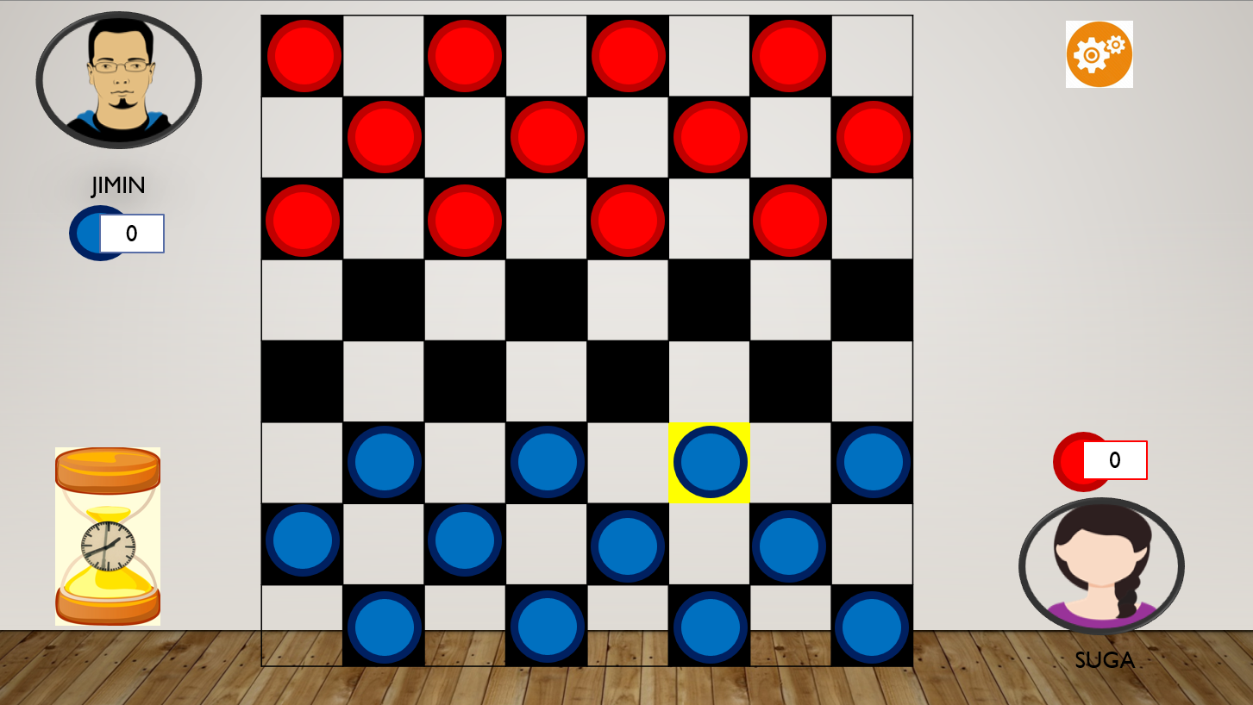

The colour of the checker for specific player is also shown with the points of that specific player.

When the cursor hits the checker, the checker is gets glow or highlighted.

Glow shows the moment of the cursor as we move the cursor around the board the specific checker under the cursor will glow.

The settings button will also be displayed on the screen

**When the player clicks on that key:**

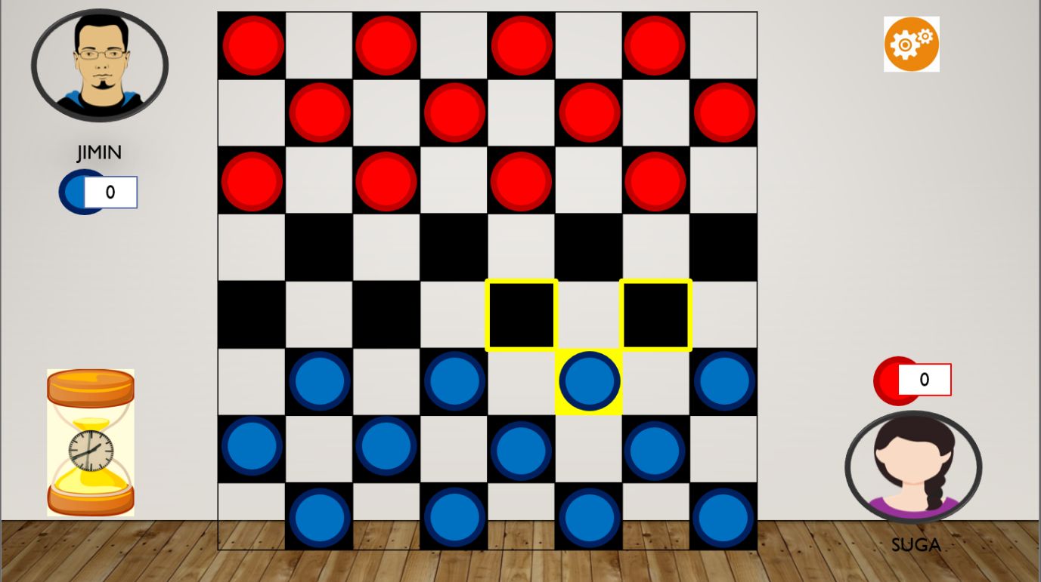

When a player clicks on a particular checker the checker will gets selected and the diagonal boxes will get highlighted.

The highlighted boxes will show where our checker will move.

The checker will highlight in diagonal direction only.

Other moves will be declared as invalid moves except diagonal moves.

**After both of users have played a move:**

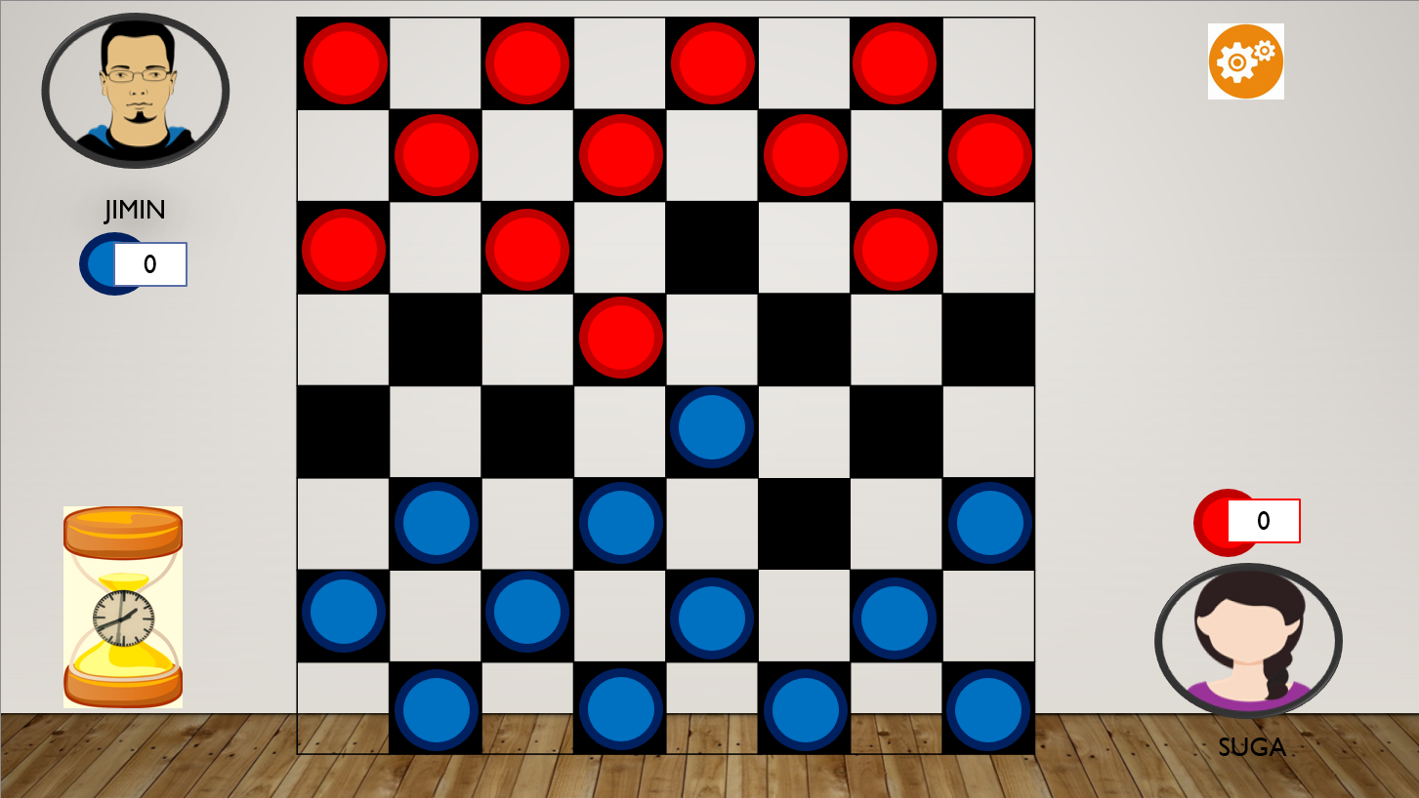

After both the users played a move, if there is a possibility of capturing the opponent, then the jump will be made and the opponent piece will be removed from the board.

In this scenario, Suga captures the piece of Jimin, so the score of Suga increases. Similarly, if Jimin captures, then his score will increase.

**Capturing a move:**

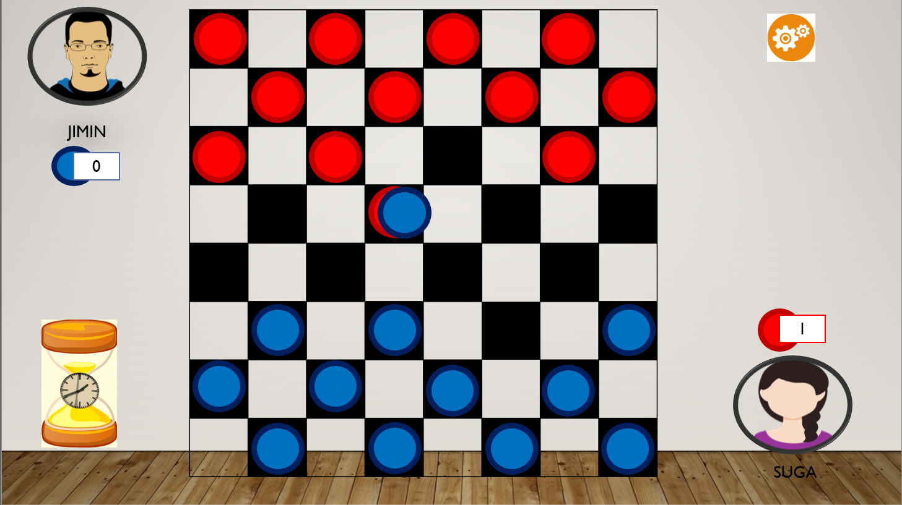

As the player players his move the we can see the moment of the checker from one place to another diagonal direction.

This game is turn based in which players play against each other.

The player captures the pieces of opponent and progresses diagonally, trying to become the winner by capturing all the pieces of opponent or blocking the opponent so that there is no legal moves left.

Trying to reach the opposite side where their pieces can be "kinged," or doubled, giving them more powers.

On the way, a player attempts to jump over her opponent's pieces and capture them.

**How the score increases!**

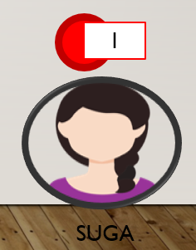

The additional points will be given to the player who captures. The game continues like this and points increases.

**Basic principle behind declaring a king:**

King should have count of token to 12 and in this case, only one of player can score 12.

**Multiple Capturing option:**

**Case 1:** When two keys are there to capture one.

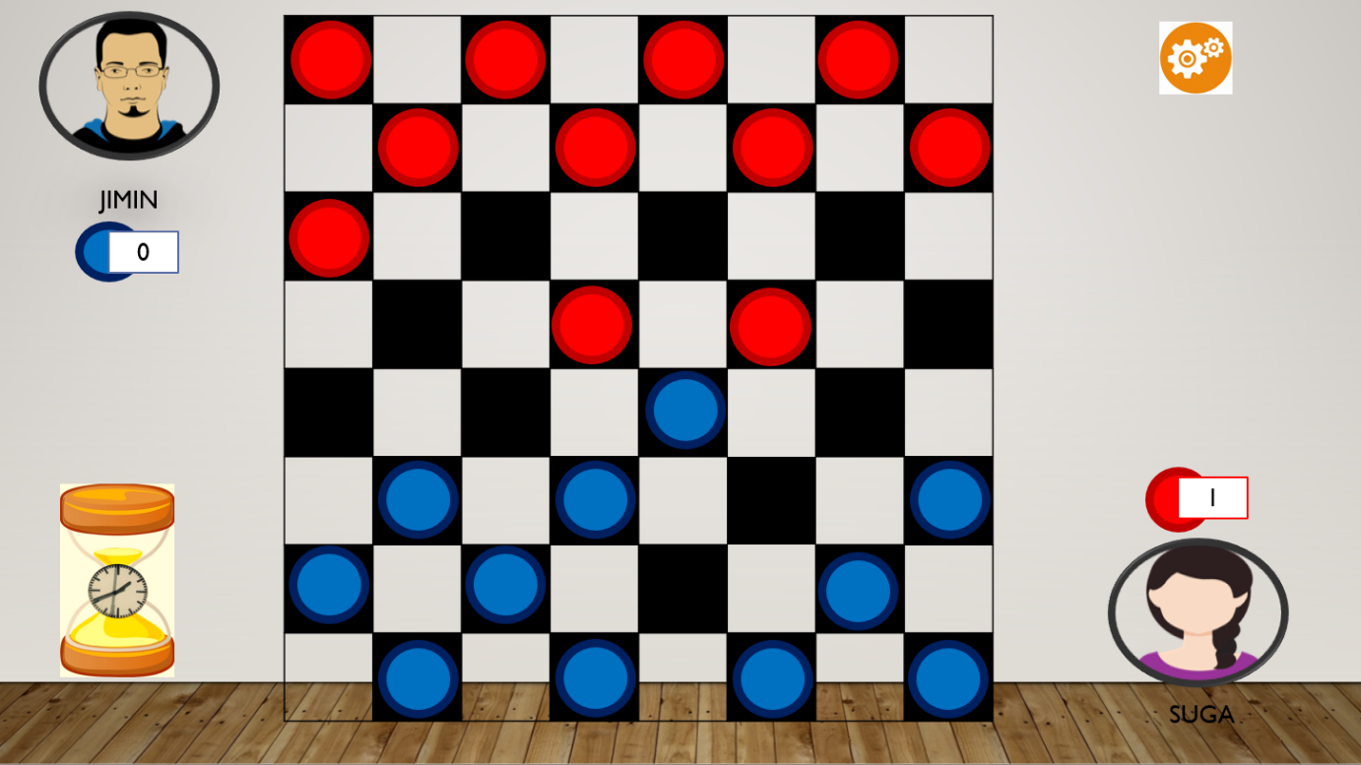

**Here,** it is the case when two red keys are there to capture one blue key.

So, if each of them has 2 chances to capture with one common blue key to strike on.

So, there will be in total three chances to capture.

So, only one out of them will capture blue key.

**Case 2:** When one key can capture two at same time.



**Here,** it is the case when two red keys can be captured by one blue key.

So, if blue key has 2 chances to capture one red blue key to strike on out of two.

So, there will be in total two chances to capture.

So, blue key can capture only one out of them.

**Crowning a King:**

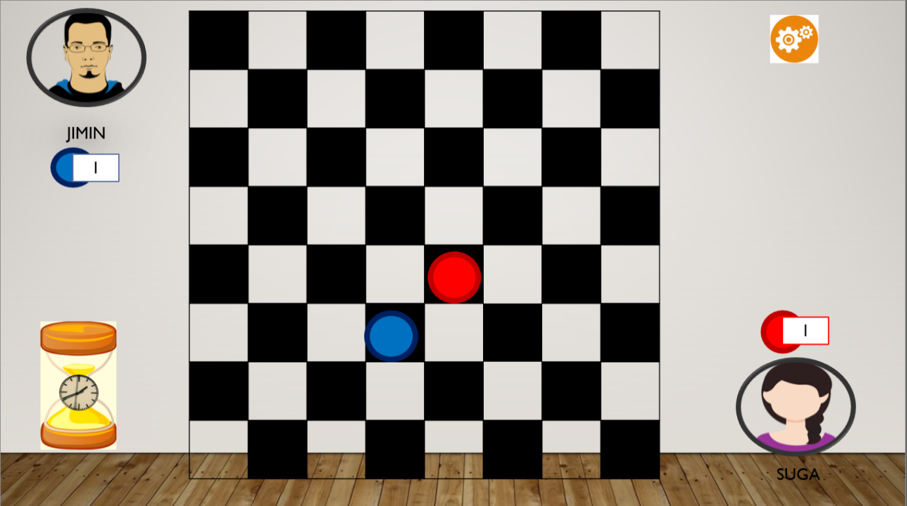

This can be only done when for once when only one key is left for one of the players playing against the opening.

The person who will capture the last token of another player will win the game of checkers.

He wins the game because he is ruling the keyboard and now no other colour tokens left on the boards.

Hence, he is the only ruler of the checker’s board.

He will crowned as the king.

**Finally Captured the token!**

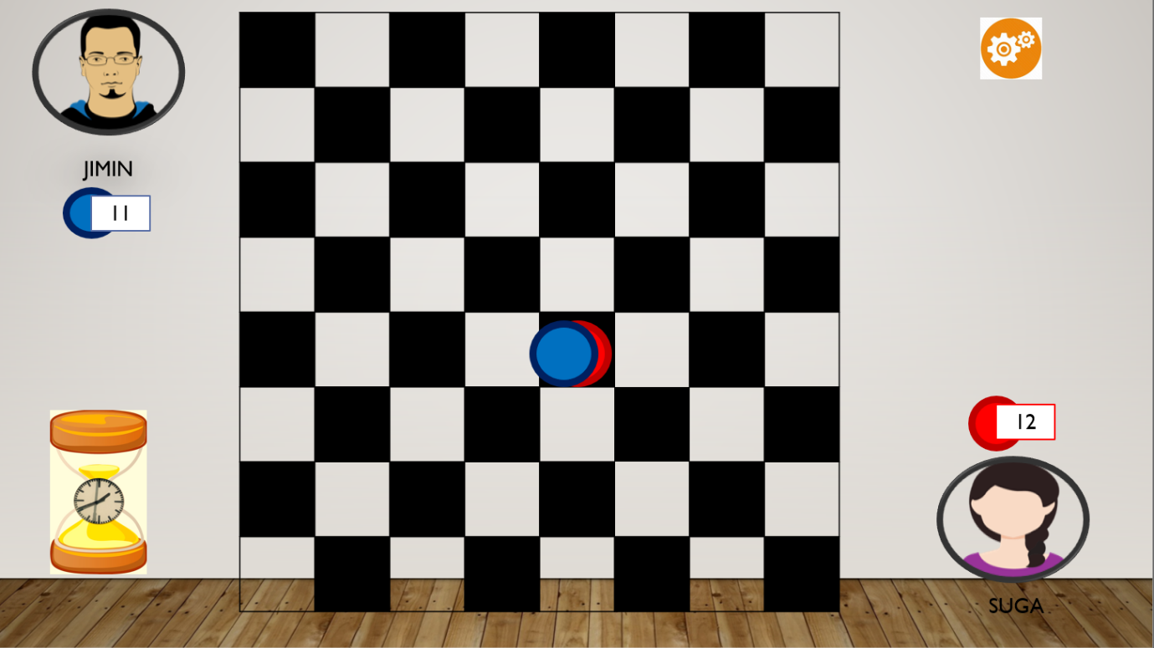

**Basic principle behind declaring a king:**

King should have count of token to 12 and in this case, only one of player can score 12.

This is again the second part how will the score will be calculated based on the results and count that is calculated by the game.

In this second blue one (Suga) is capturing the last token of the red one (Jimin). Now Suga’s score has a count of 12 and its time to end the game.

It is time to finally declare the king,

King is declaring based on the principle mentioned in the scenario.

**Comparing scores**

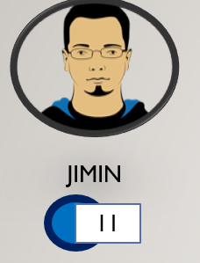 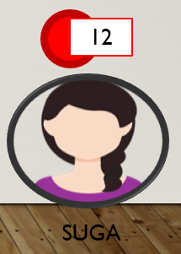

**Check the scores:**

Jimin scores = 11

Suga Scores = 12

Suga is declared as the winner!

Reason: Whenever anyone of the player playing against each other gets the score equals to 12, he/she will be declared as the king after winning the game.

**WINNER ANNOUNCEMENT:**

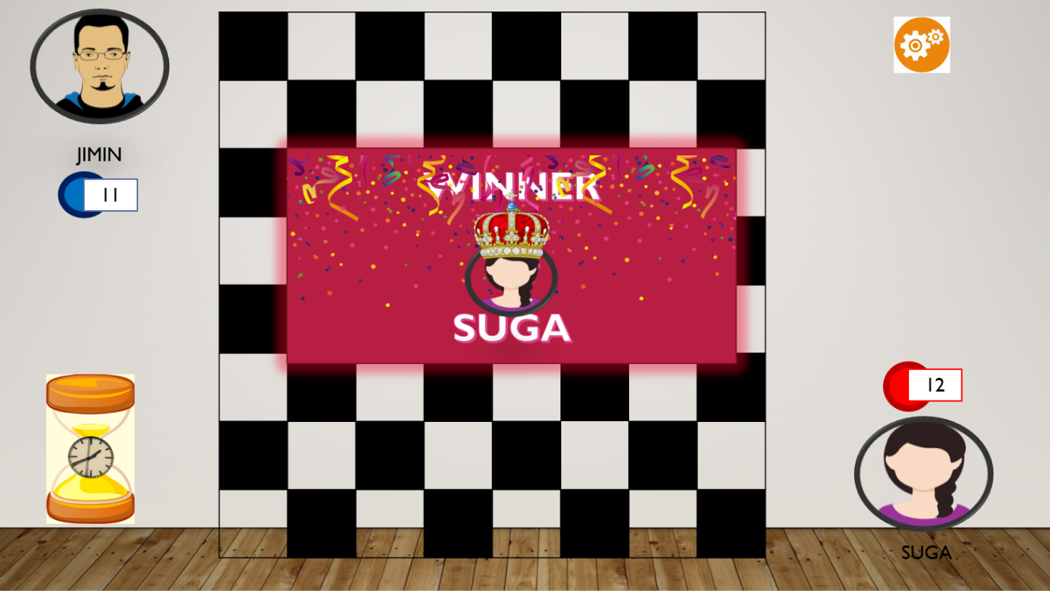

This is how the results will be shown.

Icon of the player will get the crown with written **WINNER** for it.

To get out of the game, press ESC.

Settings

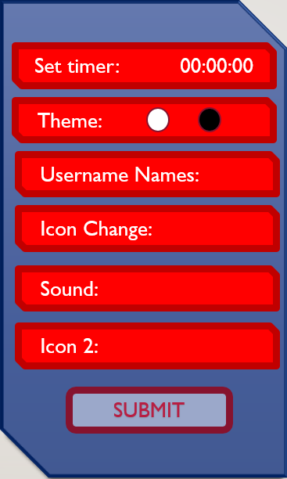

Opening Instructions:

